Software Engineering & Project
Snapshot Week 4 - BLOCK UG-16
Maptek, Block Model Compression Algorithm



Name | Student ID
Adam Dao | a1797499
Calvin McCann | a1860428
Hamidur Rahim Mahir | a1914792
Izak Stentiford | a1822100
Mohammed Ali Rezaei | a1714717
Pezhman Beheshtian | a1661736
Tyler McKinley | a1716769
Yuzhe Ma | a1918429

Product Backlog and Task Board
Product Backlog
Task | Description
Compression Algorithms Research | Research compression algorithms and create a document sharing the findings with the rest of the team
Titan Acceptance Test | Create a python file that implements the stream processor converting the input format to the output format and submit to Titan
Titan Initial Submission | Create a python file that implements the stream processor as well as a compression algorithm and submit to Titan
Snapshot 1.1 | Create snapshot 1.1
Initial Report | Create initial report
Improved Submission | Create a python file that improves on the initial submission through a faster algorithm or a more efficient algorithm
Group Charter | Create group charter
Snapshot 1.2 | Create snapshot 1.2
Snapshot 2.1 | Create snapshot 2.1
Snapshot 2.2 | Create snapshot 2.2
Snapshot 3.1 | Create snapshot 3.1
Snapshot 3.2 | Create snapshot 3.2
Snapshot 4.1 | Create snapshot 4.1
Snapshot 4.2 | Create snapshot 4.2
Snapshot 5.1 | Create snapshot 5.1
Snapshot 5.2 | Create snapshot 5.2
Sprint 1 Retrospective | Create sprint 1 retrospective
Sprint 2 Retrospective | Create sprint 2 retrospective
Sprint 3 Retrospective | Create sprint 3 retrospective
Sprint 4 Retrospective | Create sprint 4 retrospective
Sprint 5 Retrospective | Create sprint 5 retrospective
Final Presentation | Create final presentation

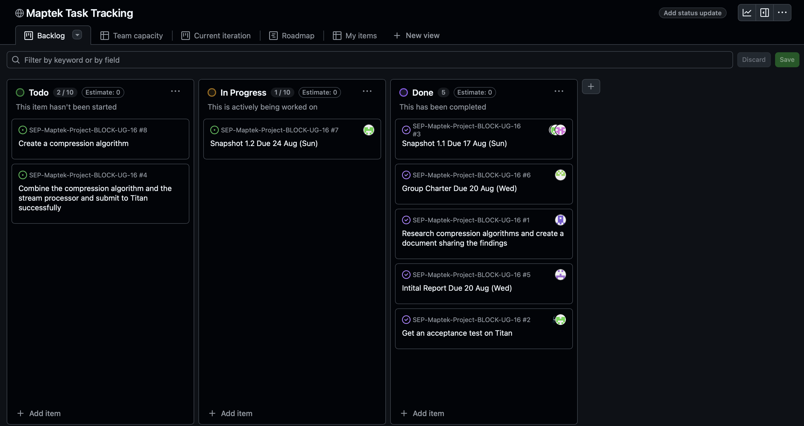
Task Board

Sprint Backlog and User Stories
Sprint Backlog
Task | Description
Compression Algorithms Research | Research compression algorithms and create a document sharing the findings with the rest of the team
Titan Acceptance Test | Create a python file that implements the stream processor converting the input format to the output format and submit to Titan
Titan Initial Submission | Create a python file that implements the stream processor as well as a compression algorithm and submit to Titan
Snapshot 1.1 | Create snapshot 1.1
Initial Report | Create initial report
Group Charter | Create group charter
Snapshot 1.2 | Create snapshot 1.2

User Stories (Sprint 1)

As a developer, we want to research existing compression algorithms so that our team can choose an efficient method for compressing block models.

As the Product Owner (TA), I want a minimal Python script that can run on Titan without errors so that I can confirm the input/output pipeline works correctly before adding complex compression.

Definition of Done
Complete the Titan Initial Submission task which involves a working submission on Titan that implements the stream processor and compression algorithm.

Summary of Changes
This week marked the second week of the project. The group had its second team meeting on 20 Aug Wednesday. The group went over the initial report and group charter and submitted them that night. The research on compression algorithms was also completed and incorporated into the initial report. The product backlog had the upcoming snapshots and retrospectives added to it, along with the final presentation and anything that was missing and should have been in it in snapshot 1.1. The sprint backlog also had the things that were missing from it added as well. The team managed to resolve the Titan login problem Friday night and successfully got an acceptance test on Titan to work that implements the stream processor in python. The goal of implementing the compression algorithm was missed, but the product owner’s user story was met.

